CALA Topic : Transport and communication

CALA Title :Transport

Part A

1. Define Transport

Transport, or transportation is the movement of people, animals, and goods from one location to another. Whether by air, on land or over water Transport **helps in the assembly of raw materials and distribution of finished goods**. It makes it possible to move goods from the place of production to the place where they are to be consumed. In the earlier days, there were only local markets due to the absence of safe means of transport. Transport is important because **it enables communication, trade, and other forms of exchange with people, that in turn establishes civilization**. Transport plays an important part in economic growth and globalization, but most types cause air pollution and use large amounts of land

b). Three modes of Transport

The different **modes of transport** are

1. AIR
2. WATER
3. LAND

C) Two goods normally transported by air are as follows

1.Perishables Foods such as Tomatoes, Meat etc

2. Drugs, vaccines, and pharmaceutical products

d)

1. Tomatoes

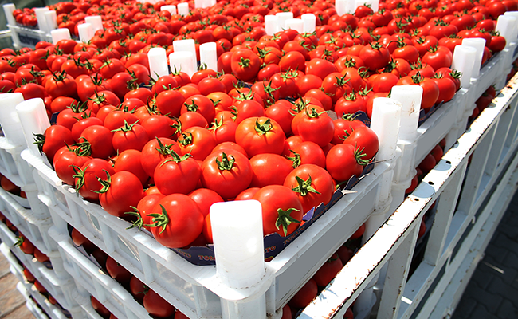

2. Vaccines

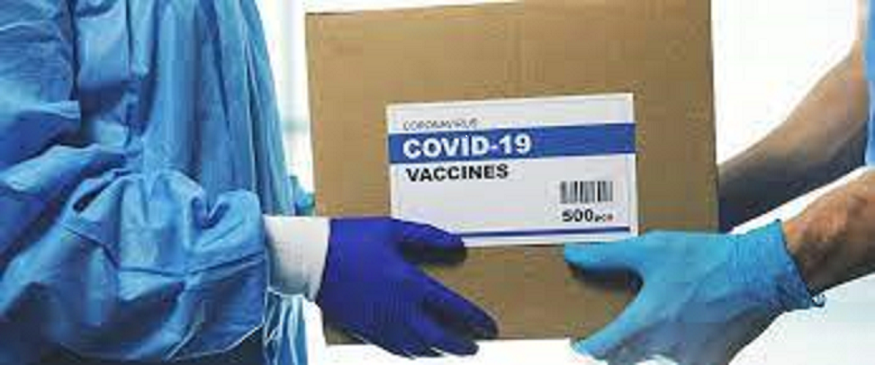

Part B

**AIR**

Air transport has many advantages over other means of transport However it also has some disadvantages which detail it below.

**Advantages of air transport**

* **Speed**. It allows you to reach any point in the world in just a few hours.
* **Accessibility**. The plane makes it possible to reach practically hidden places, where other means of transport are not able to reach.

**Disadvantages of air transport**

• **High cost.** It is significantly more expensive than other means of transport.

• **Weathe**r**.** Conditioned by the weather which can cause delays.

Land (Rail and Road)

Rail Transport

**Advantages:**

**1. Cheaper Transport:**

It is a cheaper mode of transport as compared to other modes of transport. Most of the working expenses of railways are fixed costs. Every increase in the railway traffic is followed by a decrease in the average cost. Rail transport is economical in the use of labor also as one driver and one guard are sufficient to carry much more load than the motor transport.

**2. Suitable for Bulky and Heavy Goods:**

Railway transport is economical, quicker, and best suited for carrying heavy and bulky goods over long distances.

**Disadvantages:**

**1. Lack of Flexibility:**

Another disadvantage of railway transport is its inflexibility. Its routes and timings cannot be adjusted to individual requirements.

**2. Lack of Door-to-Door Service:**

Rail transport cannot provide door to door service as it is tied to a particular track. Intermediate loading or unloading involves greater cost, more wear and tear and wastage of time. The time and cost of terminal operations are a great disadvantage of rail transport.

**Advantages and Disadvantages of Road Transport**

The two advantages of road transport in comparison to other modes of transport are as follows

**Advantages:**

**1.Door to Door Service:**

The outstanding advantage of road transport is that it provides door to door or warehouse to warehouse service. This reduces cartage, loading and unloading expenses.

**2. Flexible Service:**

Road transport has a great advantage over other modes of transport for its flexible service, its routes and timings can be adjusted and changed to individual requirements without much inconvenience.

Advantages and Disadvantages of Water Transport are as follows:

**Advantages:**

**1. Less Maintenance Cost:**

Maintenance cost in rail and road transport is quite high but maintenance cost of water transport is quite less.

**2. Cheap:**

The transport channel is quite cheap as compared rail and road Transport.

**Disadvantages of Water Transport:**

**The following are the disadvantages of water transport:**

**1. Slow Speed:**

It is a slow means of transport. Failure of monsoon results into fall in the water level of rivers making navigation difficult. this mode of transport is unsuitable where time is an important factor.

**2. Limited Area of Operation:**

It can be used only in a limited area which is served by deep canals and rivers.

Part B(ii)

Road Transport

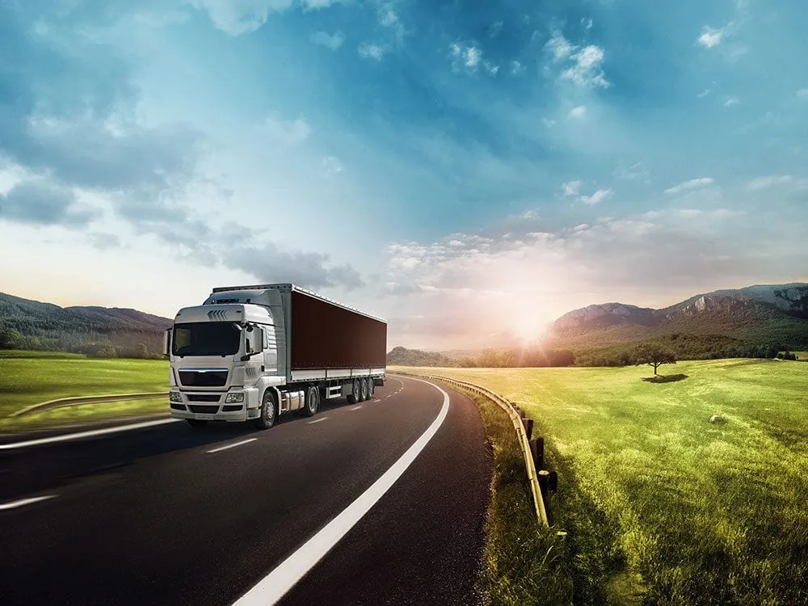

AIR Transport

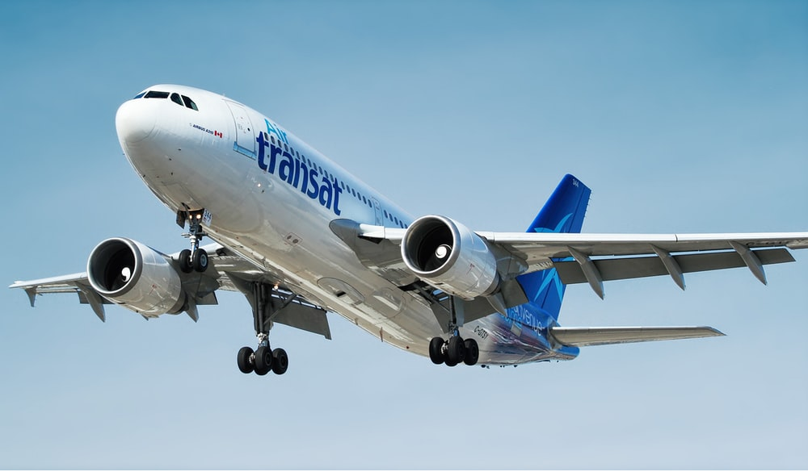

Water Transport

